**SOFTWARE ENGINEERING…..**

**Software Requirements Specification(SRS)**

**BYJU’S APPLICATION…**

**INTRODUCTION**

Byju’s is a leading ed-tech platform that offers interactive learning through video lessons, quizzes, and AI-based assessments. It provides courses for school students and competitive exams, making learning engaging and accessible. This study explores its software engineering aspects, including system design, features, and development strategies…

**OBJECTIVE OF BYJU’S**

1. **Personalized Learning:** Tailors lessons to each student's pace and needs.
2. **Engaging Content:** Uses fun videos, quizzes, and visuals to make learning easier.
3. **Expert Teachers:** Gives access to top teachers and live help.
4. **Comprehensive Curriculum:** Covers subjects from school to competitive exams.
5. **Skill Development:** Helps students improve problem-solving and critical thinking.
6. **Practice & Assessments:** Provides tests and exercises to track progress.
7. **Convenience & Flexibility:** Learn anytime, anywhere.
8. **Progress Tracking:** Shows how well students are doing and where to improve.
9. **Adaptive Learning:** Changes lessons based on student performance.

Byju's makes learning easy, fun, and flexible for everyone.

**FUNCTIONAL REQUIREMENT**

1. **User Registration and Login:**

* Allows users to create an account and securely log in to access the platform’s features and content.

1. **Course Subscription & Purchase:**

* Lets users browse, select, and purchase courses, providing access to educational content after successful payment.

1. **Video Lectures & Live Classes:**

* Provides access to pre-recorded video lessons and live, interactive classes with instructors to enhance learning.

1. **Quizzes & Assessments:**

* Offers interactive quizzes and tests to evaluate learning progress, with instant feedback to help improve knowledge.

1. **Progress Tracking & Reports:**

* Tracks users’ progress through lessons and tests, offering reports and recommendations to guide improvement.

1. **Doubt Resolution & Chat Support:**

* Allows students to ask questions and receive responses from tutors or an AI-powered system to clarify doubts.

1. **Gamification & Leaderboard:**

* Integrates rewards, points, and rankings to motivateusers, creating an engaging and competitive learning environment.

**NON-FUNCTIONAL REQUIREMENT**

1. **Performance Requirements:**

* The app should load in under 3 seconds, support adaptive video streaming, and have less than 1-second latency for live classes.

1. **Security Requirements:**

* User data must be encrypted with AES-256, include two-factor authentication (2FA), and comply with GDPR and data privacy regulations.

1. **Usability Requirements:**

* The app should be easy to navigate for students aged 6-18, accessible for differently-abled users, and support multiple languages.

1. **Availability & Reliability:**

* The app should be available 24/7 with 99.9% uptime, automatic failover, and daily cloud backups.

1. **Scalability Requirements:**

* The app should handle 10 million concurrent users and support global expansion with localized servers.

1. **Compatibility Requirements:**

* The app must work on Android (8+), iOS (12+), and web browsers, and be responsive across all devices.

1. **Maintainability & Upgradability:**

* The system should allow feature updates without downtime and release bug fixes or updates every two weeks.

1. **Legal & Compliance Requirements:**

* The app must comply with COPPA, GDPR, CCPA, and local educational regulations.

**RISKS IN BYJU’S**

**1. Technical Risks**

* **Server Downtime:** High traffic during peak hours may cause crashes.
* **Data Breach:** Risk of user data leaks due to cyberattacks**.**
* **App Bugs & Glitches:** Errors in payment processing, video buffering issues.

**2. Security Risks**

* **Unauthorized Access:** Weak authentication may lead to hacking attempts.
* **Payment Fraud**: Fake transactions or refund abuse.
* **Phishing Attacks:** Fake BYJU’S websites/apps scamming users.

**3. User Experience Risks**

* **Content Overload:** Too much information may confuse young learners.
* **Low Engagement:** If the UI is not engaging, students may lose interest.
* **Device Compatibility Issues:** Older devices may not support the app well.

**4. Financial Risks**

* **Subscription Cancellations:** High refund rates may impact revenue.
* **Monetization Issues:** Ad-based revenue may not be sufficient.
* **Economic Factors:** Parents may stop subscriptions due to financial issues.

**5. Compliance & Legal Risks**

* **Privacy Violations**: Not following GDPR, COPPA, CCPA could lead to fines.
* **False Marketing Claims:** Any misleading promises can result in lawsuits.
* **Educational Regulations:** Content must align with local education policies.

**6. Competition Risks**

* **Market Competition:** Rivals like Unacademy, Vedantu, and Khan Academy may offer better features.
* **Technology Advancements:** Failure to adopt AI-driven learning can make BYJU’S outdated.

**7. Content & Learning Risks**

* **Misinformation:** Incorrect educational content can misguide students.
* **Learning Gaps:** Some students may not understand concepts without personal guidance.

**USER STORIES**

**User Story01: Student Registration** As a new user, I want to create an account on Byju’s, so that I can access learning materials.

* Acceptance Criteria:
* Users can sign up using email, phone number, or social media.
* A verification process must be completed before account activation.
* Users should be able to set a password and update profile details.

**User Story02: Course Enrollment** As a student, I want to enroll in courses of my choice, so that I can start learning.

* Acceptance Criteria
* Students can browse and select courses.
* Payment (if required) should be processed securely.
* Course access should be granted immediately after enrollment.

**User Story 03: Video Learning** As a student, I want to watch interactive video lessons, so that I can understand concepts better.

* Acceptance Criteria
* Videos should load smoothly with different quality options.
* Users should be able to pause, rewind, and resume lessons.
* Subtitles and playback speed options should be available.

**User Story 04: Quizzes and Assessments** As a student, I want to take quizzes after lessons, so that I can test my understanding.

* Acceptance Criteria:
* Each lesson should have quizzes with multiple difficulty levels.
* Instant feedback and explanations should be provided.
* Performance tracking should be available in the user dashboard.

**User Story 05: Doubt Clarification** As a student, I want to ask questions and get answers from teachers, so that I can clarify my doubts.

* Acceptance Criteria
* A doubt-asking feature should be available for each topic.
* Responses should be provided within a specific time.
* Students can view previously asked doubts and expert answers.

**User Story 06: Progress Tracking** As a student, I want to track my progress, so that I can improve my learning.

* Acceptance Criteria
* A dashboard should display completed lessons and upcoming tasks.
* Performance reports should include strengths and improvement areas.
* Users should receive personalized study recommendations.

**User Story 07: Parent Dashboard** As a parent, I want to track my child’s learning progress, so that I can monitor their performance.

* Acceptance Criteria:
* Parents can create a linked account to view their child’s progress.
* The dashboard should show completed lessons, quiz scores, and areas for improvement.
* Notifications should be sent for low performance or missed lessons.

**User Story 08: Live Classes** As a student, I want to attend live classes, so that I can interact with teachers in real time.

* Acceptance Criteria
* Live class schedules should be available in the app.
* Students should be able to join, participate, and ask questions.
* Recordings should be available for students who miss the class.

**User Story 09: Subscription and Payment Management** As a user, I want to manage my subscription and payments, so that I can upgrade or cancel my plan as needed.

* Acceptance Criteria
* Users should be able to view and manage their subscription plans.
* Secure payment options should be available (credit card, UPI, etc.).
* Refund and cancellation policies should be clearly mentioned.

**User Story 10: Gamification and Reward** As a student, I want to earn rewards and badges for completing tasks, so that I stay motivated to learn.

* Acceptance Criteria
* Students should earn points for completing lessons and quizzes.
* Badges should be awarded for milestones (e.g., 7-day streak).

**USE CASE DIAGRAM**

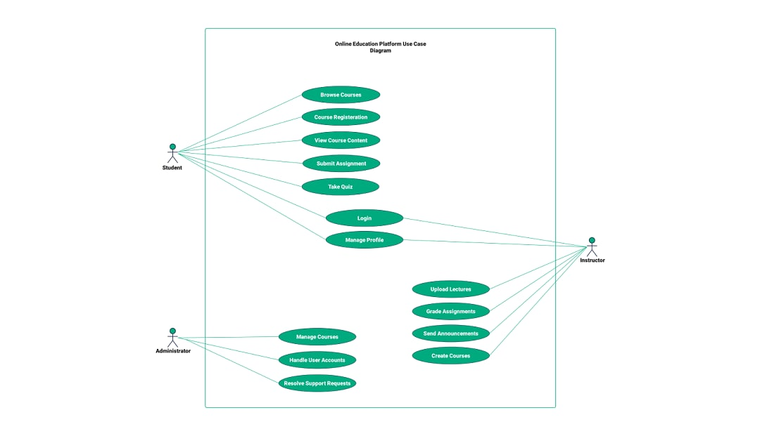

**TEST CASES**

**1. User Authentication & Registration**

* Verify that a user can register with valid details.
* Check login with valid and invalid credentials.
* Test password reset and email verification functionality.
* Verify if multi-factor authentication (if applicable) works correctly.

**2. Course Enrollment & Navigation**

* Verify if a user can search and enroll in a course.
* Test if enrolled courses appear correctly in the dashboard.
* Check if users can navigate between lessons smoothly.
* Verify if locked courses require payment before access.

**3. Video Streaming & Lesson Playback**

* Verify if videos play without buffering under normal conditions.
* Test video quality adjustments (auto, 480p, 720p, 1080p).
* Check if users can pause, rewind, and fast-forward videos.
* Test if lesson completion status updates correctly.

**4. Quiz & Assessment Functionality**

* Verify if quizzes load properly after a lesson.
* Test correct and incorrect answer submission.
* Check if scores and progress are stored and displayed correctly.
* Validate if time-bound quizzes auto-submit after the timer ends.

**5. Payment & Subscription**

* Test different payment methods (credit/debit card, UPI, wallets).
* Verify if a failed payment does not activate the subscription.
* Check refund and cancellation policies are applied correctly.
* Validate if subscription expiry restricts access to premium content.

**6. User Profile & Settings**

* Test profile updates like name, email, and password change.
* Verify if users can upload a profile picture.
* Check notification and email preferences functionality.

**7. Performance & Security Testing**

* Test application performance under heavy user load.
* Check for SQL Injection and Cross-Site Scripting (XSS) vulnerabilities.
* Verify secure data encryption for payment and personal details.
* Test logout functionality to prevent unauthorized access.

**CONCLUSION**

The SRS document for Byju’s outlines the key requirements to build a user-friendly and efficient e-learning platform. It defines functional and non-functional needs, ensuring smooth course enrollment, content delivery, assessments, and secure payments. This document serves as a blueprint for developers and stakeholders to create a scalable and high-quality system, ensuring a seamless learning experience.

Here are **test cases** for each functionality with **Description, Input, and Expected Output (5 per functionality):**

### **1. User Authentication & Registration**

| **Test Case ID** | **Description** | **Input** | **Expected Output** |
| --- | --- | --- | --- |
| **UA_001** | Verify user registration with valid details | Enter name, email, password, phone number, and OTP | User account is successfully created |
| **UA_002** | Check login with valid credentials | Enter correct email and password | User is logged in successfully |
| **UA_003** | Check login with invalid credentials | Enter incorrect email or password | Error message **"Invalid email or password"** appears |
| **UA_004** | Test password reset functionality | Click **"Forgot Password"**, enter registered email | Password reset link is sent |
| **UA_005** | Verify multi-factor authentication | Login with 2FA enabled, enter OTP | User is logged in after OTP verification |

### **2. Course Enrollment & Navigation**

| **Test Case ID** | **Description** | **Input** | **Expected Output** |
| --- | --- | --- | --- |
| **CE_001** | Verify course search functionality | Enter a course name in the search bar | Relevant course results are displayed |
| **CE_002** | Check if a user can enroll in a course | Click **"Enroll Now"** for a free course | Course appears in the dashboard |
| **CE_003** | Verify that enrolled courses appear in the dashboard | Enroll in a course | Enrolled course is visible in the dashboard |
| **CE_004** | Check if users can navigate between lessons | Click **"Next"** and **"Previous"** buttons | User can navigate smoothly |
| **CE_005** | Verify locked courses require payment | Click on a locked course | **"Payment required"** message appears |

### **3. Video Streaming & Lesson Playback**

| **Test Case ID** | **Description** | **Input** | **Expected Output** |
| --- | --- | --- | --- |
| **VS_001** | Verify video playback | Click on a lesson video | Video plays without buffering |
| **VS_002** | Test video quality adjustments | Change quality to 480p, 720p, 1080p | Video quality changes accordingly |
| **VS_003** | Verify pause, rewind, and fast-forward functions | Click **Pause**, **Rewind**, **Fast-Forward** | Video responds correctly |
| **VS_004** | Check lesson completion status update | Watch a lesson completely | Lesson status updates to **"Completed"** |
| **VS_005** | Verify video buffering under poor network | Play video with slow internet | Video buffers or shows low-quality playback |

### **4. Quiz & Assessment Functionality**

| **Test Case ID** | **Description** | **Input** | **Expected Output** |
| --- | --- | --- | --- |
| **QA_001** | Verify if quizzes load properly | Click **"Start Quiz"** after a lesson | Quiz loads without issues |
| **QA_002** | Test correct answer submission | Select a correct answer and submit | Answer is marked correct |
| **QA_003** | Test incorrect answer submission | Select a wrong answer and submit | Answer is marked incorrect |
| **QA_004** | Verify quiz progress tracking | Complete a quiz | Scores and progress update correctly |
| **QA_005** | Validate auto-submit for time-bound quizzes | Wait until timer runs out | Quiz auto-submits with saved answers |

### **5. Payment & Subscription**

| **Test Case ID** | **Description** | **Input** | **Expected Output** |
| --- | --- | --- | --- |
| **PS_001** | Verify successful payment processing | Enter valid credit/debit card details and pay | Payment is successful, subscription activates |
| **PS_002** | Verify payment failure handling | Enter incorrect card details | Error message **"Payment failed"** appears |
| **PS_003** | Check refund and cancellation policies | Request a refund for a subscription | Refund is processed as per policy |
| **PS_004** | Validate subscription expiry restrictions | Access premium content after subscription expiry | Access is restricted |
| **PS_005** | Verify multiple payment methods | Pay using credit card, UPI, wallet | All payment methods process correctly |

### **6. User Profile & Settings**

| **Test Case ID** | **Description** | **Input** | **Expected Output** |
| --- | --- | --- | --- |
| **UP_001** | Test profile update functionality | Change name, email, or password | Updated details are saved successfully |
| **UP_002** | Verify profile picture upload | Upload a new profile picture | Picture updates correctly |
| **UP_003** | Check notification settings | Enable/disable push/email notifications | Settings update accordingly |
| **UP_004** | Verify email preferences change | Subscribe/unsubscribe from emails | Preferences update successfully |
| **UP_005** | Test logout functionality | Click **"Logout"** button | User is logged out and redirected to login page |

### **7. Performance & Security Testing**

| **Test Case ID** | **Description** | **Input** | **Expected Output** |
| --- | --- | --- | --- |
| **PS_001** | Test application performance under heavy load | Simulate multiple users accessing simultaneously | App should handle traffic without crashing |
| **PS_002** | Check SQL Injection vulnerability | Enter SQL queries in input fields | App should prevent unauthorized queries |
| **PS_003** | Verify Cross-Site Scripting (XSS) protection | Enter <script>alert("XSS")</script> in input fields | Script should not execute |
| **PS_004** | Verify secure data encryption | Check if passwords are stored as plaintext | Passwords should be encrypted |
| **PS_005** | Test session expiration handling | Stay inactive for a set duration | User is logged out automatically |

### **Final Notes**

* **Total test cases:** **35 (5 per functionality)**
* Covers **User Authentication, Course Navigation, Video Playback, Quizzes, Payment, Profile Management, and Security**
* Ensures **functionality, performance, security, and user experience**

Would you like me to format this for **Excel or JIRA test case upload**? 😊